KQL: first query to troubleshooting evidence
  - Portal-first beginner hands-on lab
LBS | Attendee edition v2 | 26 October 2026

Before you start
Environment: use the instructor-approved sandbox, group, region, tiers and spending limit. Create only your own disposable resources. The walkthrough uses fictional data. No cloud resource is created by reading this document.
Materials: copy Labs\AppServiceSqlSample locally when the lab needs the .NET sample. Complete its setup from 02_Windows_And_Local_SQL_Setup.docx. Do not repeat resource creation if you already completed the same lab in the main guide.
Admin assistance: Contributor does not automatically grant IAM role assignment, SQL SELECT, Blob data access or Service Bus data access. Have the authorised administrator perform only the privileged step. Never bypass policy.
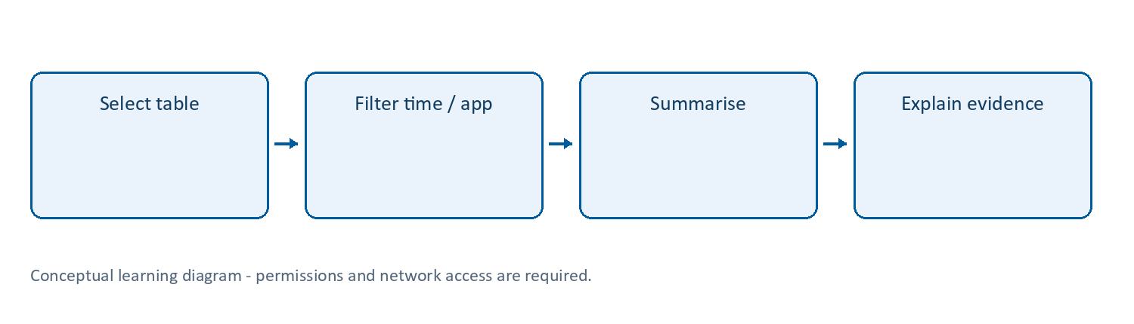
Learning flow

KQL | Ask questions of telemetry
What: Kusto Query Language is a read-oriented query language used by Azure Monitor Logs and other products. A pipeline takes a table and applies operators such as where, project, summarize and order by.
Why/when: quickly filter a failure period, count errors or compare durations without writing an application. It is not T-SQL and is not used here to update business database rows.
How: select a workspace/time range, inspect a table, filter time and your resource first, then project/group only the needed columns. Follow Lab 8.
Read this aloud: AppRequests | where TimeGenerated > ago(1h) | take 10 means “start with stored request telemetry, keep the last hour, return up to ten rows.”
Tips and traps: KQL is case-sensitive in many places. == compares strings case-sensitively; =~ is case-insensitive. Use has for term matching where suitable, and contains for substring matching. A count of stored rows is not necessarily a total request count under sampling. Filter early; avoid an unbounded search of every table.
Reference: https://learn.microsoft.com/kusto/query/tutorials/learn-common-operators

Lab 8 | KQL investigation and troubleshooting (core)
Time: 75-90 minutes. Needs: Lab 7, query access and generated traffic.
These queries use Log Analytics workspace tables (AppRequests, AppDependencies, AppExceptions, AppTraces) and TimeGenerated. Application Insights resource-context queries can instead use requests, dependencies, exceptions, traces and timestamp. Do not mix their column names. If tables are missing, inspect the selected workspace and connected resource.

8A. Find requests and identify your app
AppRequests
| where TimeGenerated > ago(2h)
| project TimeGenerated, AppRoleName, Name, ResultCode,
Success, DurationMs, OperationId, _ResourceId
| order by TimeGenerated desc
| take 50
Select a row from your app. In a shared workspace, add | where AppRoleName == "<actual-role-name>" or filter _ResourceId to your Application Insights resource ID immediately after the time filter in every relevant query. Do not read other learners’ telemetry unnecessarily.

8B. Request volume, failure count and latency
AppRequests
| where TimeGenerated > ago(2h)
| summarize SampledRows=count(),
FailedRows=countif(Success == false),
P95Ms=percentile(DurationMs, 95)
by bin(TimeGenerated, 5m)
| order by TimeGenerated asc
These are stored-row counts, not guaranteed total traffic counts when sampling is enabled. For an approximate represented total, inspect and sum ItemCount; do not label count() as all production requests without checking sampling.

8C. Find SQL dependencies
AppDependencies
| where TimeGenerated > ago(2h)
| where DependencyType contains "SQL"
| project TimeGenerated, Name, Target, Success,
DurationMs, OperationId
| order by DurationMs desc
| take 20
No rows may mean the API did not call SQL, the instrumentation does not collect the dependency, the time filter is wrong, or ingestion is delayed. Do not infer “SQL is healthy” from an empty table.

8D. Exceptions
AppExceptions
| where TimeGenerated > ago(2h)
| project TimeGenerated, ExceptionType, OuterMessage,
InnermostMessage, OperationId
| order by TimeGenerated desc
| take 20

8E. Correlate one operation
Copy an OperationId from a failed request:
let operation = "<paste-operation-id>";
union withsource=TableName
AppRequests, AppDependencies, AppExceptions, AppTraces
| where TimeGenerated > ago(2h)
| where OperationId == operation
| order by TimeGenerated asc
Explain the sequence: incoming request, SQL dependency, exception, returned response. The sample’s log TraceId is not automatically the same field as every telemetry OperationId; use actual stored correlation values.

8F. Controlled failure in your sandbox only
- Do this only in your own disposable web app with instructor approval. Never break a shared or production app.
- Record the original configuration securely. Temporarily change the app setting’s database name to LbsTrainingMissing, apply and call /api/items once.
- Restore the original setting immediately, apply, and verify /api/items succeeds before investigating.
- Find the failed request and related SQL dependency/exception. Record time range, result code, operation ID, cause and verification of recovery.
If permissions do not permit fault injection, use the instructor’s prepared failure. Do not invent a result if telemetry did not arrive.

8G. Offline KQL fallback
If live application telemetry is unavailable but you have workspace query access, this self-contained query practises filtering and summarising without ingesting data:
let Demo = datatable(Name:string, Success:bool, DurationMs:real)
[
"GET /health", true, 10.0,
"GET /api/items", true, 42.0,
"GET /api/items", false, 300.0
];
Demo
| summarize Rows=count(), Failures=countif(Success == false),
AverageMs=avg(DurationMs) by Name
This validates KQL syntax practice only, not live monitoring. If no query workspace is available, review the query and predicted result with the instructor.
Checkpoint: save three working queries and a short incident record with evidence and a verified recovery.

Lab 16 | KQL from first result to a saved visualisation
What/why: move from viewing isolated rows to answering a question that another engineer can repeat.
Needs: Lab 8 telemetry and workspace query access. Cost: query costs depend on table plan/features; use the approved Analytics tables, bounded time ranges and small results.
- Open the correct workspace Logs, switch to the query editor and inspect AppRequests columns.
- Start with AppRequests | where TimeGenerated > ago(30m) | take 5.
- Add a resource/role filter for your own app, using an actual value from a row.
- Generate ten bounded requests as in Lab 7, then run:
AppRequests
| where TimeGenerated > ago(30m)
| where AppRoleName == "<actual-app-role-name>"
| summarize StoredRows=count() by bin(TimeGenerated, 5m)
| order by TimeGenerated asc
| render timechart
- Select the chart view if the editor does not switch automatically. Explain that StoredRows can differ from generated requests because of sampling/time filters/ingestion.
- Choose Save or Save as query. Use your personal/approved query pack if available; creating a query pack may require additional permission. Name it LBS request rows last 30 minutes.
- If saving centrally is blocked, save the query text in your own course notes. That is a fallback, not a successful shared query-pack deployment.
- In Azure Monitor > Workbooks, create a new workbook if authorised. Select Edit > Add query, choose Logs, the correct workspace and the same query without the final render line if the workbook’s visualisation control expects it separately.
- Select a timechart visualisation, run and save in your group with an explicit title such as LBS lab requests. Verify the saved workbook loads and respects access.
- Share only with the intended training audience. A workbook does not bypass the underlying data permissions.
Expected: a working filtered chart and a saved query; a workbook if your access permits.
Security/log notes: filter shared workspaces to your app, use UTC/time-zone awareness, never put tokens in query literals, and do not export all raw rows for convenience.
Cleanup: delete only your practice workbook/query if no longer needed; retain useful non-sensitive KQL text.
Reference: https://learn.microsoft.com/azure/azure-monitor/visualize/workbooks-overview

Completion record and cleanup
Record | Your observation
Subscription/group/region and actual resource names
Expected result and actual result
Log/table/metric, time range and evidence
Identity, role/scope and network restrictions
Idle/usage/logging cost driver
Cleanup or retention owner/deadline
Only mark a lab passed after its functional checkpoint. A deployment success or empty error table alone is not proof. Mark blocked permissions honestly.
Clean up only your own disposable objects; removing a diagnostic setting does not erase retained logs, and stopping an app does not stop every cost. Follow Lab 13 in the main guide. Keep secrets/customer information out of evidence.
Verification scope: these instructions and Word file structure were reviewed. Automated Word pagination could not be completed; preview before printing. Azure execution, prices, policy, permissions, plan/runtime availability and portal labels require instructor rehearsal in the actual training subscription.

